THE WARRNAMBOOL & DISTRICT FOOTBALL UMPIRES ASSOCIATION HANDBOOK 2023

Statement of Purpose | Approval Date: | 10/05/2022
 | Review Date: | TBD
 | Version No: | 1

The Objectives of The Warrnambool and District Umpire Association are to:

conduct, promote, and administer football umpiring in the local area;

advance football umpiring in the local area through development programs and the acquisition of relevant grants and sponsorships;

provide a safe and quality sporting / volunteer / social experience for its members;

operate as an incorporated organisation, that provides football umpire participation for its members, in accordance with association rule and by-laws;

act on behalf of and in the interest of its members and members of the local community;

affiliate and liaise with local football leagues and governing bodies to support and advance football umpiring in the local area;

affiliate and liaise with the local government agencies and other representative sporting bodies to support and advance football umpiring in the local area;

have regard to public interest and the local environment in all aspects of its operations; and

undertake what is necessary to advance these Objectives.

2023 Child Safety Declaration
Child safety and wellbeing is a key priority of the Warrnambool and District Football Association and we hereby declare our commitment to creating an environment that is safe and welcoming for all children and young people to participate in Australian Football.
To achieve this, our Club is committed to implementing the Victorian Child Safe Standards through our Commitment Statement on Child Safety, the Club’s Child Safety & Wellbeing Policy, Code of Conduct, Complaints and Reporting Procedure policies. These policies and procedures when applied ensures compliance with Safeguarding Children Standards and will :
- Establish a culturally safe environment in which diverse and unique identities and experiences of Aboriginal children and young people are respected
- Embed child safety and wellbeing in organisational leadership, governance and culture
- Empower children and young people so they know their rights, participate in decisions affecting them and are taken seriously
- Inform and engage families in respect to child safety and wellbeing
- Ensure that equity and diversity is upheld through our policies and practices
- Engage volunteers and officials to ensure that they are suitable to work with children and young people
- Respond to complaints and concerns promptly, thoroughly and with a child focused approach
- Educate staff, game day personnel and volunteers to provide them with knowledge and skills how to create a safe and welcoming environment for children and young people at our Club
- Understand and mitigate the risks to children and young people in physical and online environments
- Review and improve our child safe policies, procedures and practices regularly
- Role model behaviour and actions documented in policies, procedures and practices guiding how our Club is safe for Children and Young People
Our Club has zero tolerance to any form of child abuse or harm and will act quickly and in the best interest of the child or young person should an allegation of harm or abuse occur.
To meet the above expectations, our Club will:
Commit to:
- Discuss and sign this declaration as a committee to formally endorse our commitment
- Promote this declaration and our commitment to creating a safe and welcoming environment for all children and young people through our Club network (Club notice board, social media pages, email and newsletter correspondence)
- Appoint a child safeguarding officer and promote their details to families/members/volunteers
Implement:
- Regular discussion occurs at Club meetings to action the Child Safe Standards
Learn and embed a culture of child safety in our Club through:
- Discussion with children, young people and their families – everyone can “have a say”
- Education through awareness workshops and safeguarding resources
- Regular review of safeguarding policies and procedures with our Club committee

Contents
1. General information
The Fair Play Code
Committee and Coaches
Director of Umpiring Expectations
Association uniform
Membership Fees / Process
Match Payments.
Ground information

- Policies and Procedures Link – WDFUA Bi-Laws

- Workplace Safety

- Reporting a player or official – Handy hints

- Games Tally

- Valued Sponsors 2023

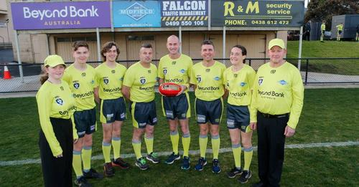
Fair Play Code (Association Values) | Approval Date: | 10/05/2022
 | Review Date: | TBD
 | Version No: | 1.

Principles
The Fair Play Code outlines a set of guiding principles on expected standards of behaviour for every person involved in sport and recreation in Victoria.
All Warrnambool and District Umpire Association members should demonstrate the principles of integrity, respect, responsibility, fairness and safety in relation to sport, recreation, training and club sanctioned activities by:
Integrity
- being honest, fair, respectful, trustworthy, reliable, open and transparent in dealings with others
- avoiding any real or perceived conflicts of interest
- striving to earn and sustain a high level of community trust and goodwill
- not engaging in or advocating the possession and use of banned performance enhancing substances or methods, or illicit drugs
  - not participating in, or encouraging action that may jeopardise the integrity of sport and recreation including match-fixing, illegal sports betting and other corruption.
Respect
- treating everyone involved in sport and recreation in a considerate, objective and courteous manner with proper regard for their rights, dignity and worth
- refraining from any form of discrimination, harassment, bullying, abuse, child abuse, intimidation, victimisation or vilification of others, including on the basis of age, race, sex, disability, sexuality, gender identity or religion
  - recognising and valuing the contribution of all to sport and recreation, including volunteer coaches, officials and administrators who give up their valuable time to make sport and recreation happen.
Responsibility
- considering and accepting the consequences of one’s actions and decisions
- being a positive role model by displaying self-control, respect, care and diligence towards all involved with sport and recreation
- complying with specified child safe standards of conduct expected of adults when dealing and interacting with persons under 18 years of age
  - understanding the possible consequences of breaching the Fair Play Code and immediately reporting any potential breaches to appropriate authorities.
Fairness
- understanding and playing by the rules and spirit of sport and recreation
- being informed, consistent, impartial, just and reasonable in dealings with others
- being a ‘good sport’ by encouraging and praising fair play over winning at all costs
  - providing a ‘fair go’ to people of all abilities to be involved in sport and recreation and reach their full potential.

Safety
- providing a safe, welcoming and inclusive environment that places the health, welfare and well-being of participants above all else
- taking all reasonable steps to ensure equipment, facilities and programs meet health and safety standards and are appropriate to the age and ability of participants
- being aware of and supporting policies and practices in relation to injury management, return to play, adverse weather and child safe standards
- showing concern and caution towards others who may be sick or injured and immediately reporting any safety issues to appropriate authorities.

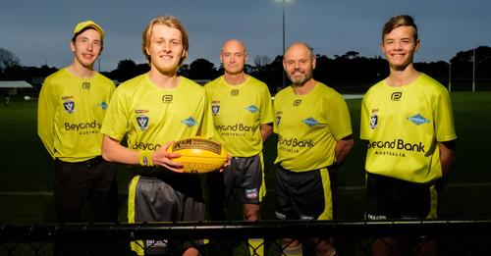

Committee 2023

President: Gavin Sell 0406 097 241 gavin.sell83@bigpond.com

Vice President: Jamie Lake 0400 955 173

Portfolio
Andrew Taylor
Steve Walker
Anthony Smith
Caitlin Kavanagh
Josh McMahon
Leigh McNaughton
Mark Robson

Coaching Panel 2023

Director of Umpiring:

Field Coach | Mick Lowther
Boundary Coach | Mal Clapp
Goal Coach | Dedy Frebie
Fitness Coach | Scott Barclay
BUMP Coach | Cait Kavanagh

1.2 Director of Umpiring expectations | Approval Date: | 24.07.22
 | Review Date: | TBD
 | Version No: | 1.

Subject to appointed DOU seasonal expectations.

Senior grand final selection criteria:
- Attendance / Participate in 70 % training sessions
- Attendance 70% of coaching sessions fortnightly - Wednesday nights after training.
- Attendance 70 % discussion nights post training on the ground.
- Coaching sessions will be available on the web page fortnightly (to be put up in the days following Wednesday training/coaching sessions)
- Umpiring Ability
- Attitude/Ethics towards the association
- If have work or travel commitments simply advise the Director of Umpiring. This does not put you out of the running for senior grand finals.

Training:
- Fair play code to be demonstrated by all members.
- Senior training is Monday (fitness) and Wednesday (fitness and drills) nights commencing at 6 pm.
- Junior training (BUMP) is Wednesday night at 515pm
- Train to your limitations.
- Whistles required for Wednesday night training sessions only
- Returning from any injury advise training coach prior to training commencing.
- Mark your name off in the training attendance book before training. List will be removed by 7pm the day of training.
- You must put in a full training session if you want to be considered for Hampden League appointments.

Game day appointments:
Provisional appointments are sent out on Monday night after 8pm access via website and email.
- Official appointments are sent out on Wednesday night after 8 pm access via website and email.
- Website access – www.wdfua.com.au
  - Click Members
  - Click Appointments
  - Enter password Umpires2022 and press enter
  - Download PDF file

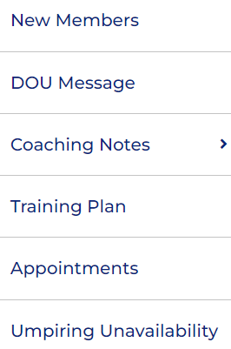

Game day unavailability:
- Log unavailability via the website. This should be done prior to Sundays for the preceding week end.
- Website access – www.wdfua.com.au
  - Click Members
  - Click Umpiring Unavailability
  - Fill box using free text - asterisk boxes mandatory
  - Press submit – the DOU will receive submission.

Coaching session:
- Coaching /discussion sessions will involve discussions around certain topics revolving around match day.
- Notes available on the website sessions.
- Website access – www.wdfua.com.au
  - Click Members
  - Click Coaching Notes
  - Select relevant session to access information
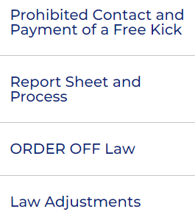

Driving to the game:
- For games outside of Warrnambool the Association organises drivers to take umpires to the game.
- For Games in Warrnambool please find your own way to the ground. Aim to be there at least 1 hour before the game commences (seniors) and 40 minutes (juniors).
- Drivers have a full licence and have car insurance.
- Check appointments for designated drivers and their contact phone number.
- The appointments also have the car departure time; this is a fixed time. If you are not present at this time you will need to find your own way to the game (a penalty might apply if this occurs)
- If you intend to find your own way to the game you need to notify the driver of your intentions (a penalty might apply if you do not).
1.3 Association Uniform | Approval Date: | 10/05/2022
 | Review Date: | TBD
 | Version No: | 1.

Off Field Uniform
Senior Umpires
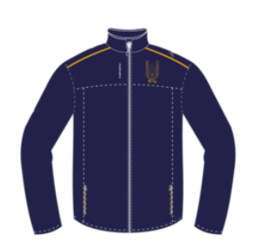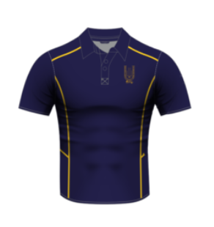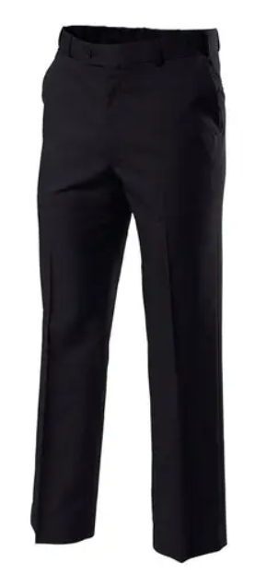
Black Dress Pants or Chinos. Black dress shorts permitted
Junior Umpires
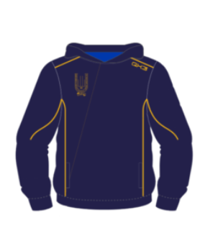
Training Top

Officiating Uniform Central and Boundary.
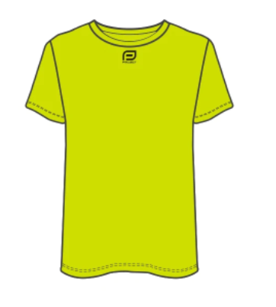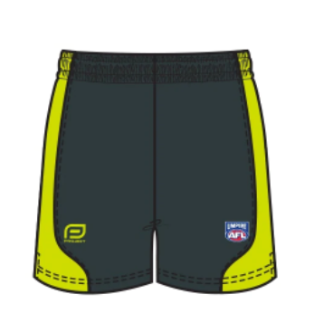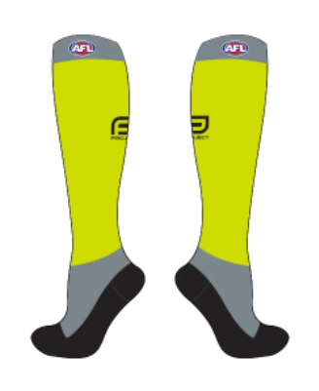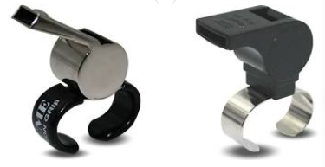

Officiating Uniform Goal
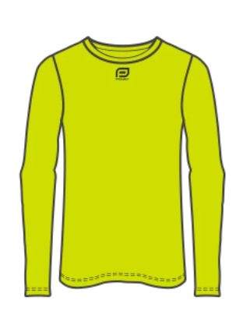
Black Dress Pants
Membership Fees / Process

Umpiring Member (Senior and Junior)

To be officially appointed to umpire at any level with the WDFUA Inc. you need to be a member and also registered with the AFL HQ.

Social Member

Social membership is family based and includes all members in the family over the age of eighteen. There is a separate Form on the internet to fill in to be considered.

Member | Association Membership Fee | VCFUA Registration Fee
Social
Senior member
Junior member
Life member

Process -

Access the website: www.wdfua.com.au

Click on

Click on link and fill out form

Click on link and fill out form

Notes:

Social members only have to fill out separate social form.

Parents also need to fill out driving permission form.

Drivers need to fill out separate drivers form.

**** All officiating members and volunteers need a Working with Children Check ****
1.9 Match Payments | Approval Date: | 2022
 | Review Date: | 2023
 | Version No: | 1

Hampden League Seniors
Field x1 | $161.00
Field x2 | $161.00
Field x3 | $161.00
Boundary x1 | $86.20
Boundary x2 | $86.20
Boundary x3 | $86.20
Boundary x4 | $65.10
Goal x1 | $70.50
Goal x2 | $70.50

Hampden League Reserves
Field x1 | $112.10
Field x2 | $112.10
Field x3 | $75.70
Boundary x1 | $63.70
Boundary x2 | 63.70
Boundary x3 | 43.50
Boundary x4 | 33.30
Goal x1 | 52.80
Goal x2 | 52.80

League U/18.5
Field x1 | $88.70
Field x2 | $88.70
Field x3 | $60.50
Boundary x1 | $49.70
Boundary x2 | $49.70
Boundary x3 | $34.10
Boundary x4 | $26.30
Goal x1 | $42.70
Goal x2 | $42.70

Hampden League U/16
Field x1 | $69.20
Field x2 | $69.20
Field x3 | $47.00
Boundary x1 | $42.70
Boundary x2 | $42.70
Boundary x3 | $29.40
Boundary x4 | $22.80
Goal x1 | $40.30
Goal x2 | $40.30

Hampden League U/14
Field x1 | $50.50
Field x2 | $50.50
Field x3 | $34.60
Boundary x1 | $35.70
Boundary x2 | $35.70
Boundary x3 | $24.70
Boundary x4 | $19.30
Goal x1 | $35.70
Goal x2 | $35.70

WDFNL Seniors
Field x1 | $127.50
Field x2 | $127.50
Field x3 | $127.50
Boundary x1 | $73.70
Boundary x2 | $73.70
Boundary x3 | $73.70
Boundary x4 | $55.70
Goal x1 | $57.30
Goal x2 | $57.30

WDFNL Reserves
Field x1 | $84.00
Field x2 | $84.00
Field x3 | $56.90
Boundary x1 | $48.10
Boundary x2 | $48.10
Boundary x3 | $48.10
Boundary x4 | $36.80
Goal x1 | $43.50
Goal x2 | $43.50

WDFNL U/18
Field x1 | $76.20
Field x2 | $76.20
Field x3 | $51.70
Boundary x1 | $43.50
Boundary x2 | $43.50
Boundary x3 | $43.50
Boundary x4 | $33.50
Goal x1 | $42.70
Goal x2 | $42.70

WDFNL League U/15
Field x1 | $69.20
Field x2 | $69.20
Field x3 | $47.00
Boundary x1 | $42.70
Boundary x2 | $42.70
Boundary x3 | $42.70
Boundary x4 | $32.75
Goal x1 | $40.30
Goal x2 | $40.30

Reviewed annually.

The association takes 22% for running costs including honorariums and utilities.
These figures depict what umpires receive in their weekly payments

Ground Information

Location of umpires change rooms denoted by
Ground entrance denoted by

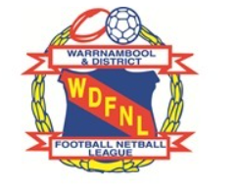
Warrnambool and District Football Netball League

Timboon Demons Football Netball Club

Timboon Recreation Reserve
Curdies River Road, Timboon, 3268
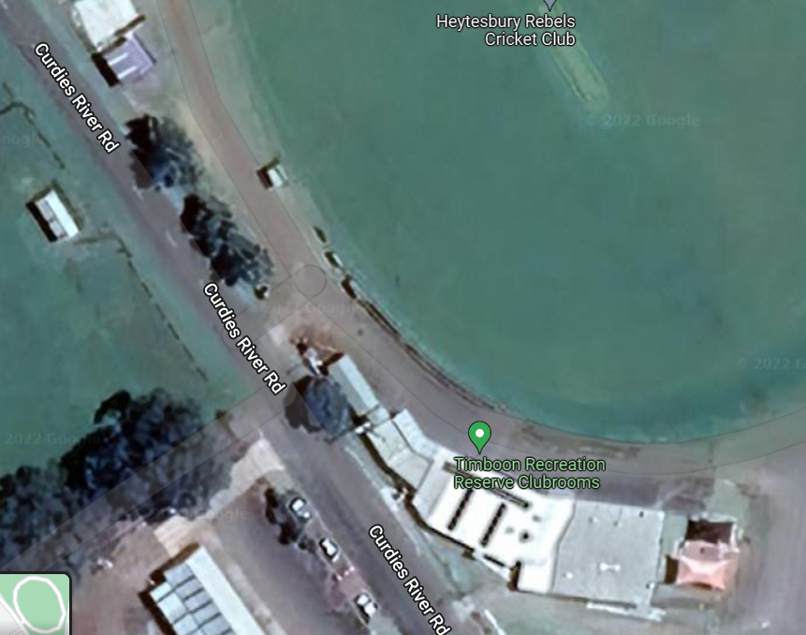
Noorat Recreation Reserve
McKinnons Bridge Road, Noorat, 3265
Kolora Noorat Netball Football Club

Noorat Recreation Reserve.
McKinnons Bridge Road, Noorat, 3265.
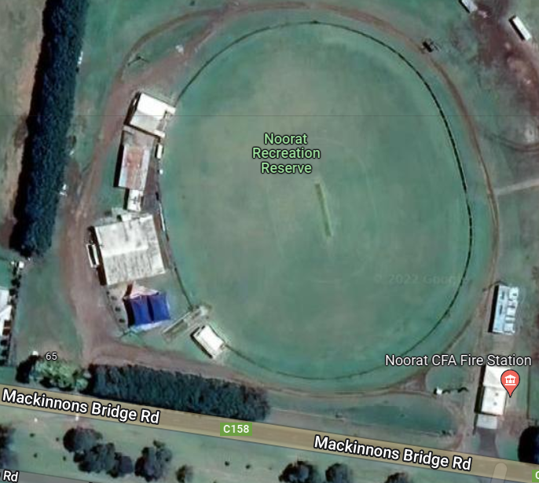

Nirranda Netball Football Club

Nirranda Recreation Reserve
39 Blakes Road, Nirranda, 3268.
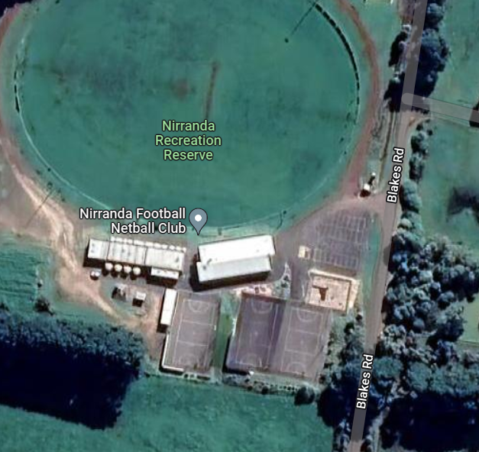

Allansford Football Netball Club.

Allansford Recreation Reserve.
Ziegler Parade, Allansford, 3277.
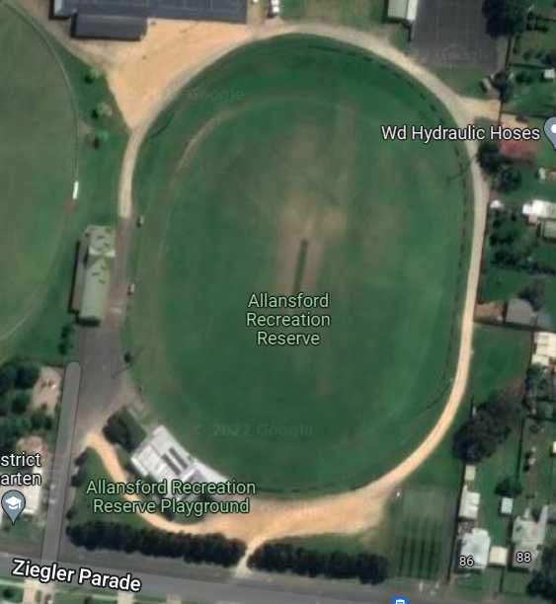

Dennington Football Netball Club.
Dennington Recreation Reserve.
2 Station Street, Dennington, 3280.
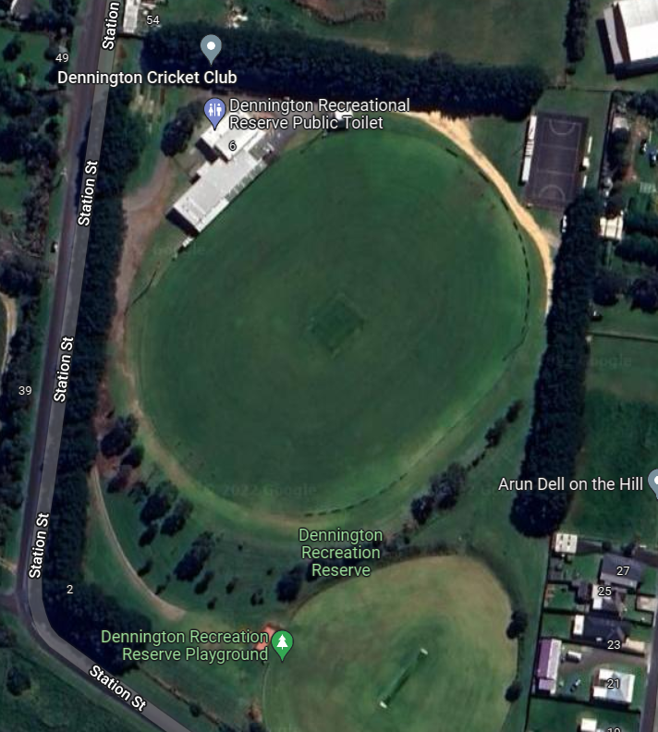

Merrivale Football Netball Club
Merrivale Recreation Reserve.
178-188 Merrivale Drive, Warrnambool, 3280.
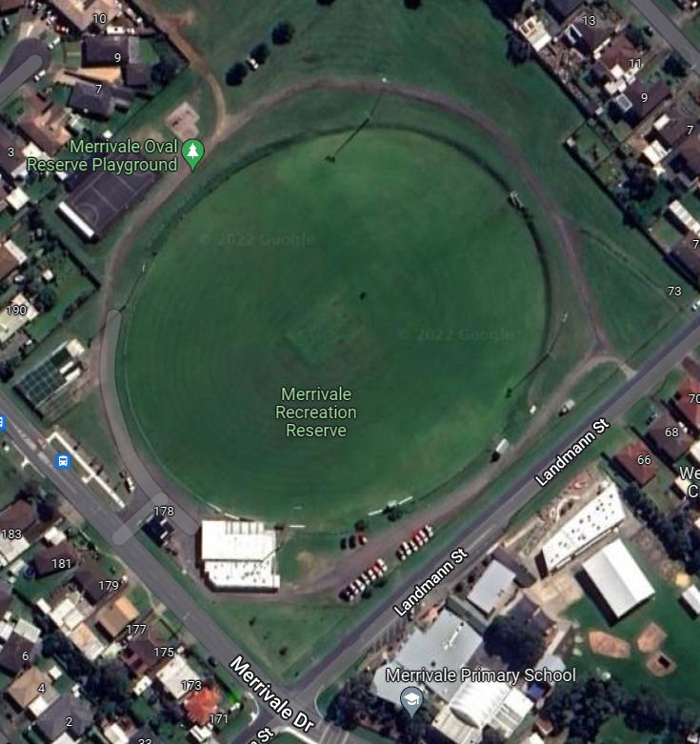

Panmure Football Netball Club
Panmure Recreation Reserve.
Church Lane, Panmure, 3265.
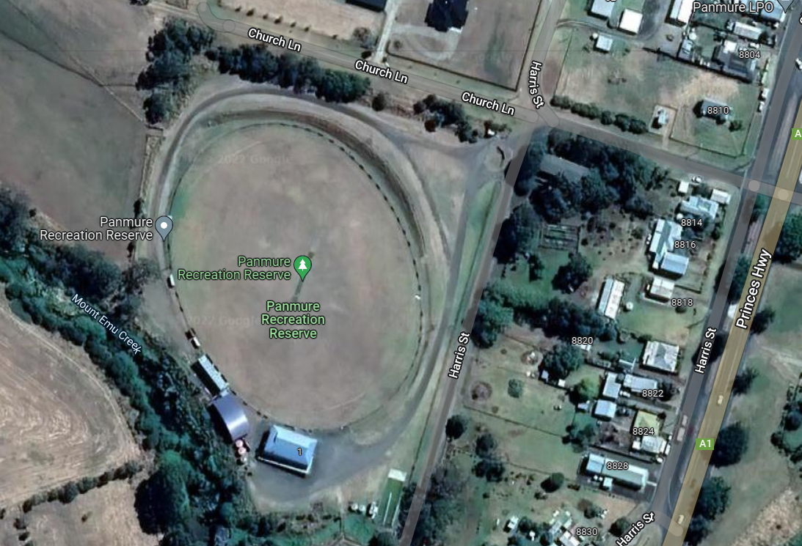

Old Collegians Football Netball Club

Davidson Oval.
14-20 Caramut Road, Warrnambool, 3280.
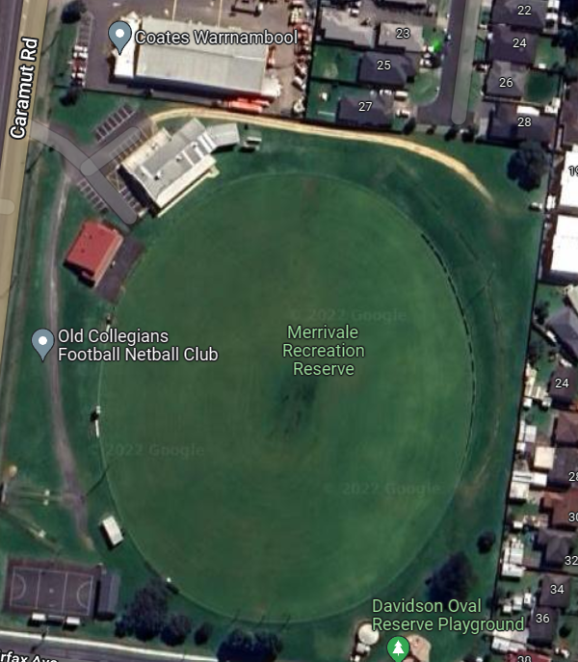

Russells Creek Football Netball Club.
Mack Oval.
39 Grafton Road, Warrnambool, 3280.
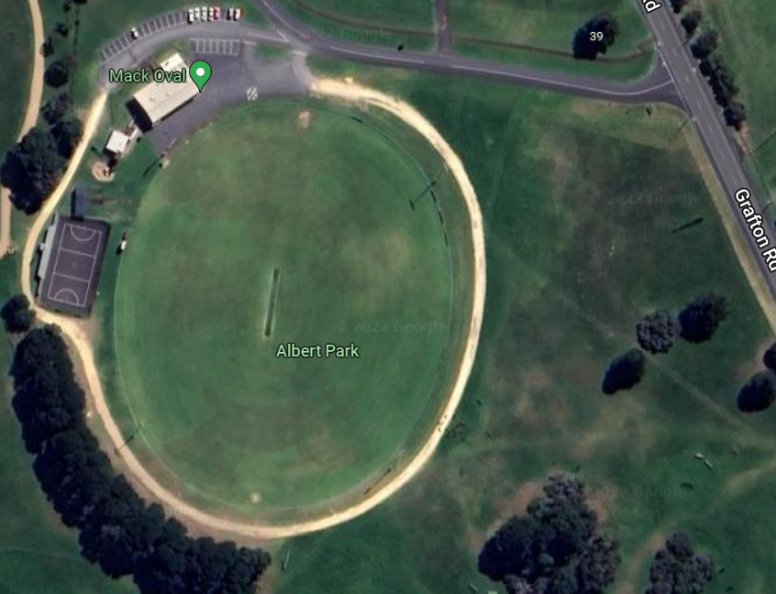

South Rovers Football Netball Club
Walter Oval
100 Coulstock Street, Warrnambool 3280
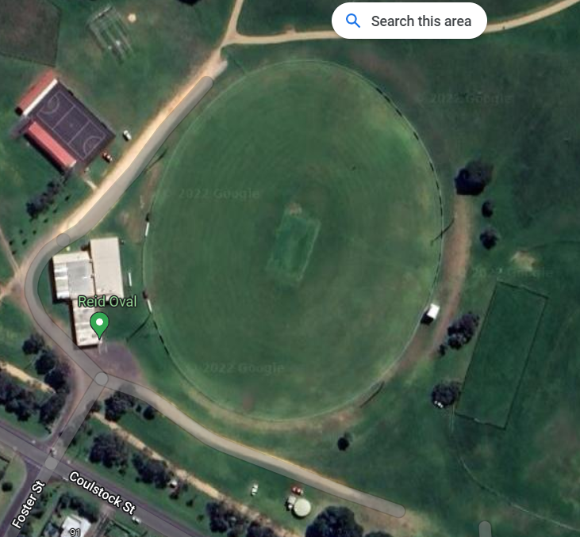

Hampden Football Netball League

Cobden Football Netball Club

Cobden Recreation Reserve
Parrott Street, Cobden, 3266
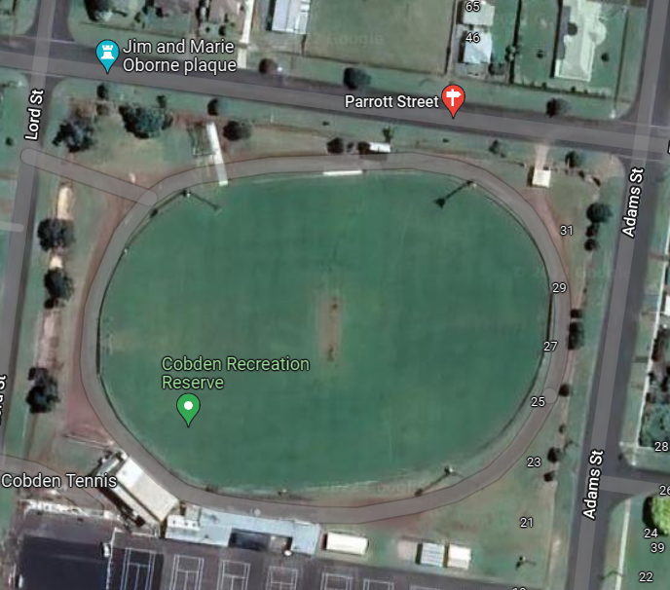
Terang Mortlake Football Netball Club

Terang Recreation Reserve
Strong Street, Terang, 3264
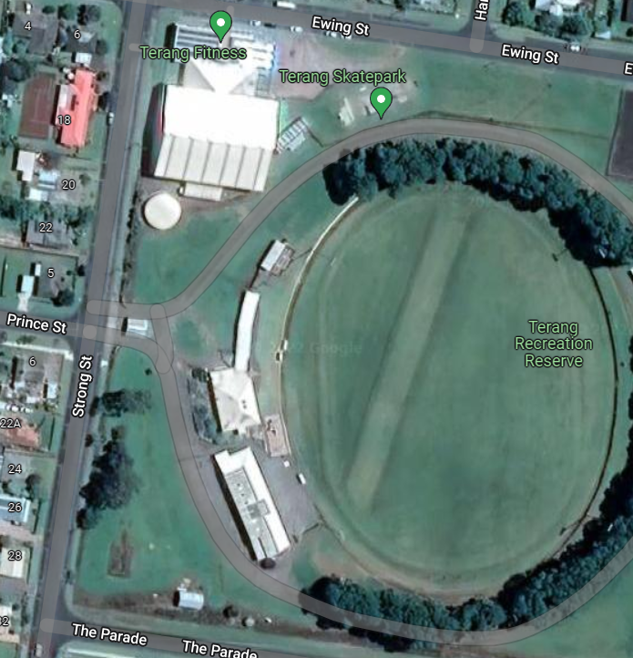

Mortlake Recreation Reserve
Officer Street, Mortlake, 3272
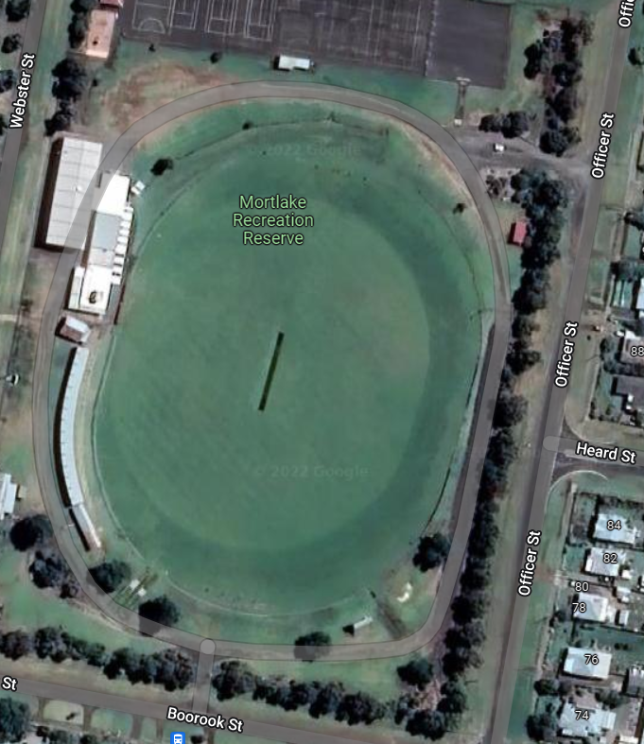

Camperdown Magpies Football Netball Club
Leura Oval
Adeney Street, Camperdown, 3260
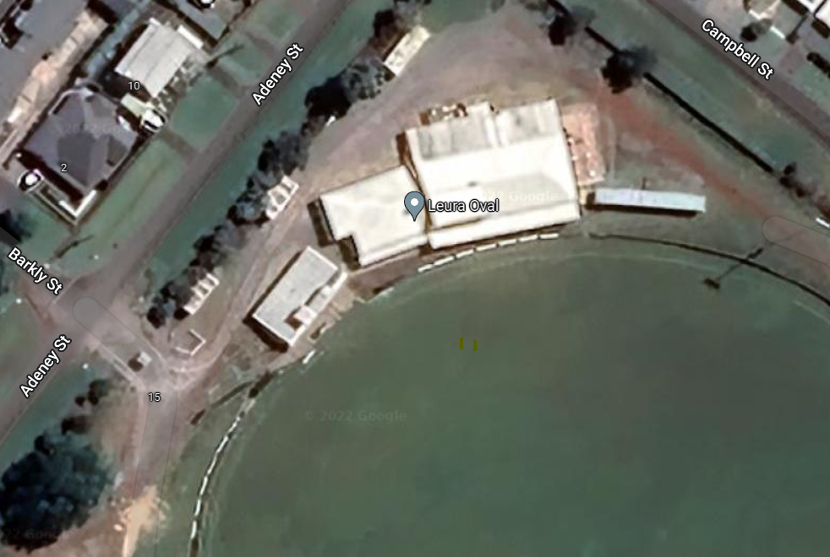

Koroit Football Netball Club
Victoria Oval
High Street, Koroit 3282

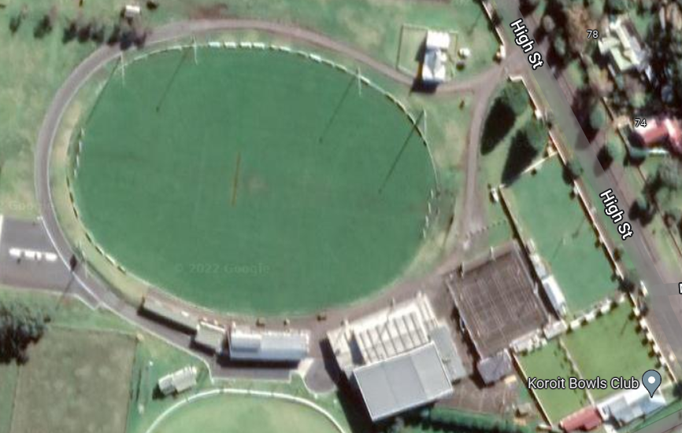

Port Fairy Football Netball Club.

111 Griffiths Street, Port Fairy, 3284.
Located in Gardens Caravan Park accessed via Bourne Avenue.
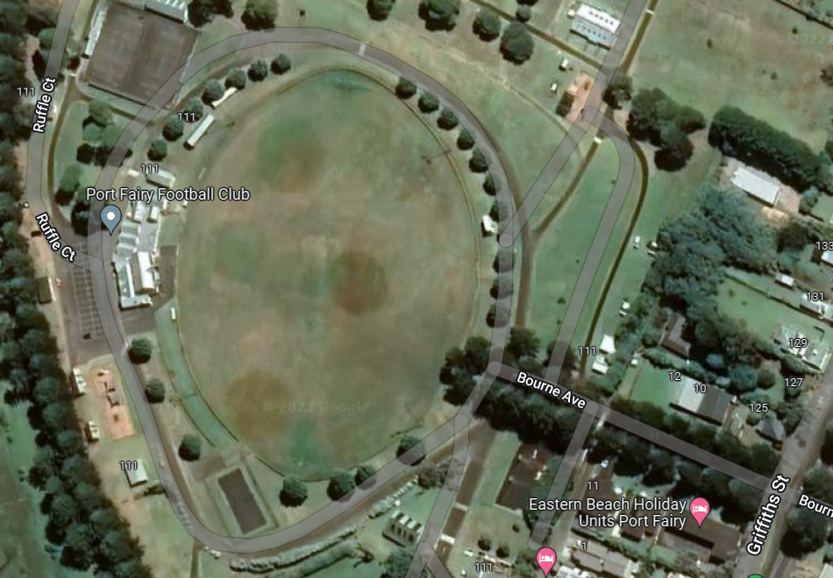

Hamilton Kangaroos Football Netball Club
Melville Oval.
Brown Street, Hamilton, 3300.
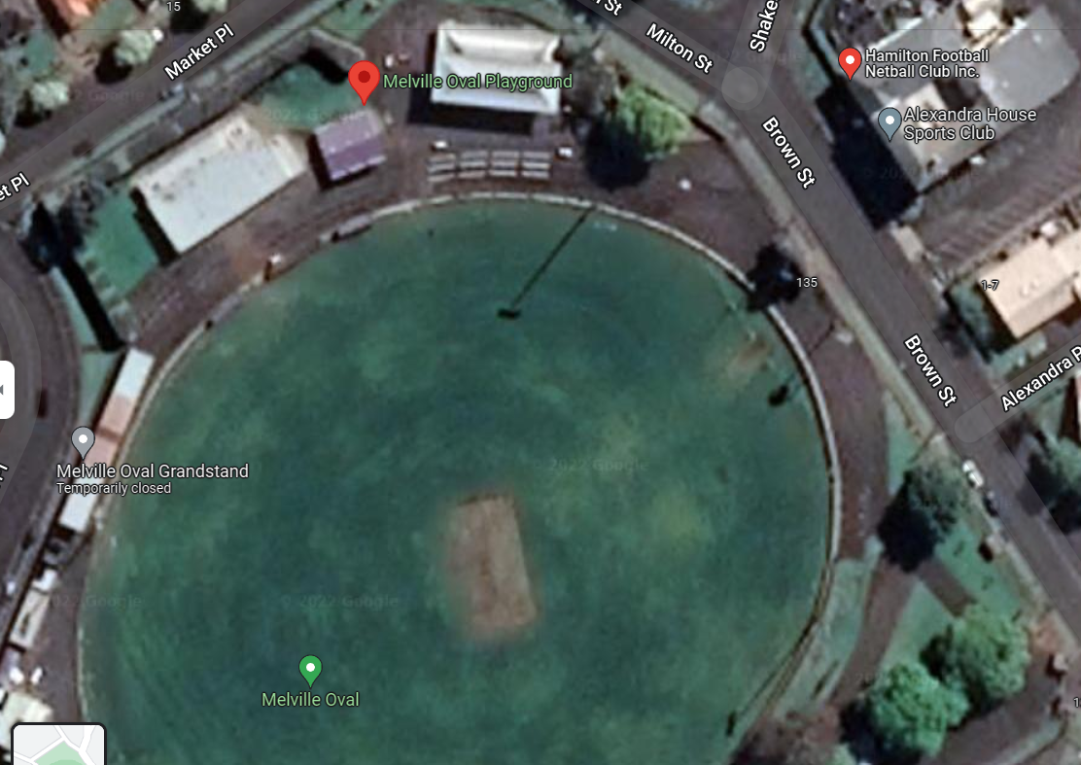

North Warrnambool Eagles Football Netball Club

Bushfield Recreation Reserve
594 Hopkins Highway, Bushfield, 3281.
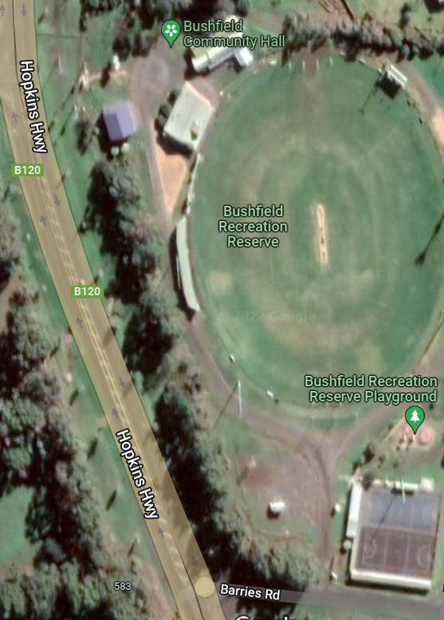

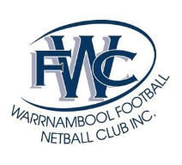 Warrnambool Football Netball Club
Reid Oval
46 Cramer Street, Warrnambool, 3280.
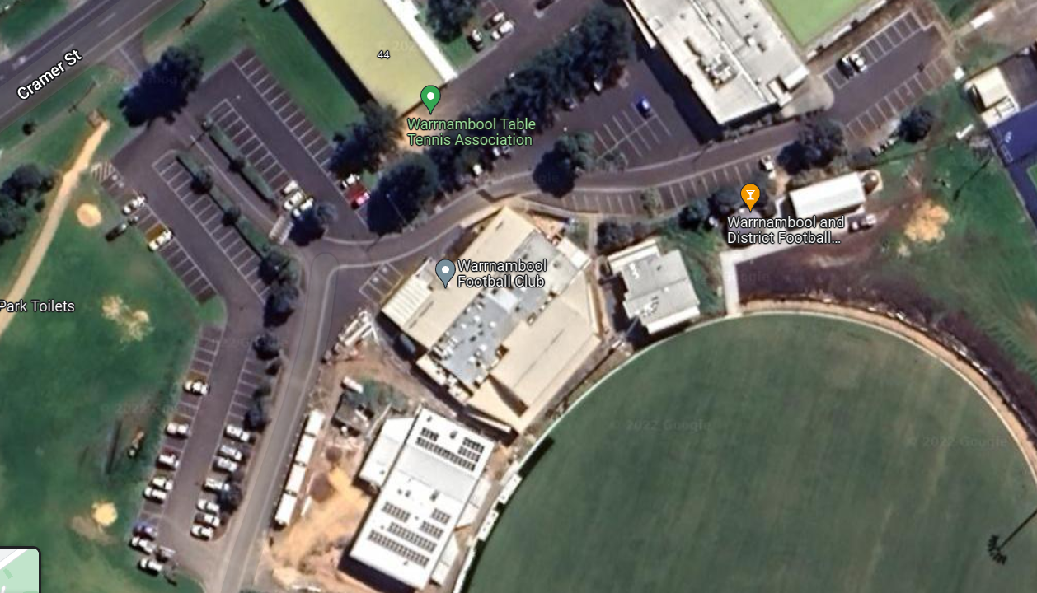
T Training entrance
Game day entrances

South Warrnambool Roosters Football Netball Club

Friendly Societies Park.
57 Hyland Street, Warrnambool, 3280.
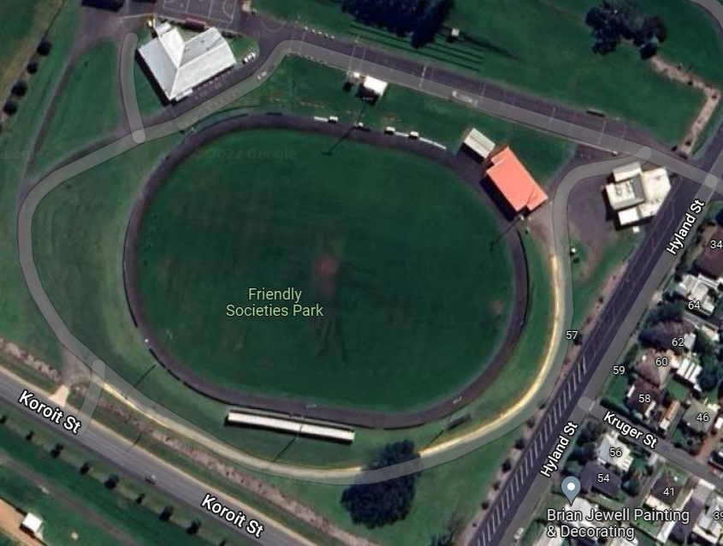

Portland Football Netball Club
Hanlon Park.
Henty Street, Portland, 3305
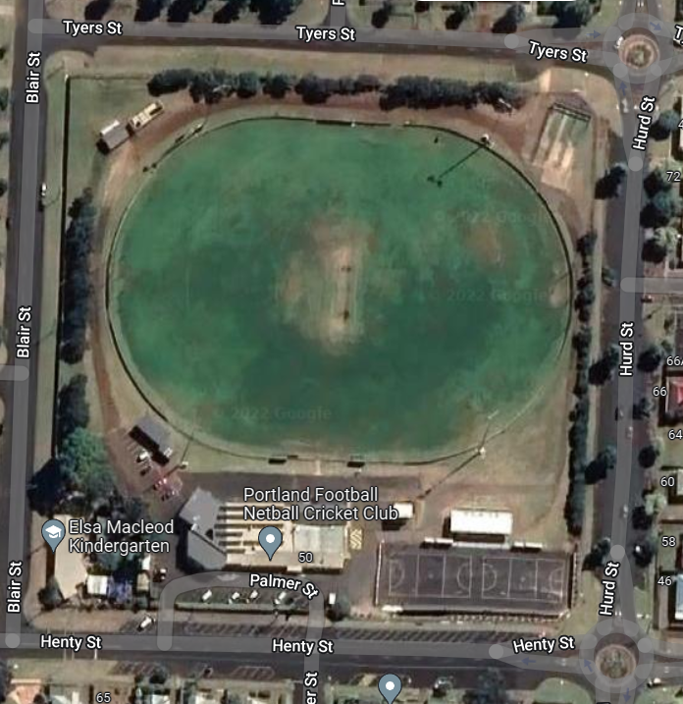

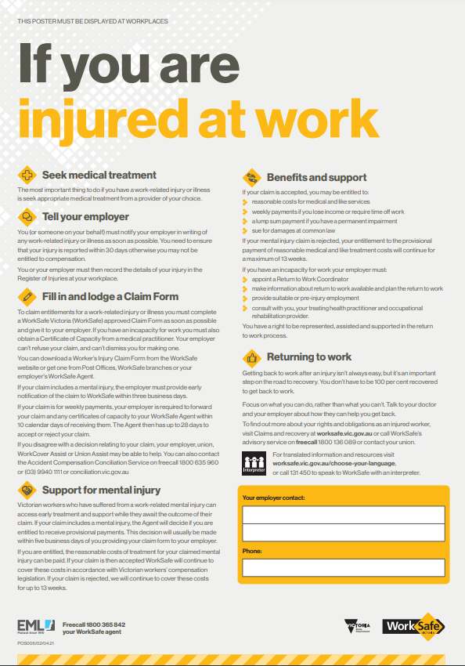

Return to work guidance: Warrnambool and District Umpire Association

1) Returning to work: A guide for injured workers - This guide contains information and ideas to help you get back to work and your normal routine. It explains the return-to-work process and the support that is available to help you.

https://www.worksafe.vic.gov.au/resources/returning-work-guide-injured-workers

2) Return to work arrangements form

https://www.worksafe.vic.gov.au/resources/return-work-arrangements-form

3) Guiding you through return to work = Some information for employers on what you need to do to give your employee the best possible chances of returning to work and thriving.

https://www.worksafe.vic.gov.au/resources/guiding-you-through-return-work
4) Simple document explaining your legal rights and obligations and what meeting them looks like in practice.
https://www.worksafe.vic.gov.au/resources/information-workers-return-work-obligations

5) Information for employers: Return to work obligations
Supporting your injured worker to return to safe and sustainable work as soon as possible is necessary to meet your legal obligations, is good for your worker and is good for business. Here’s how.

https://www.worksafe.vic.gov.au/resources/information-employers-return-work-obligations

6) Information for workers: Return to work obligations –

Simple document explaining your legal rights and obligations and what meeting them looks like in practice.

https://www.worksafe.vic.gov.au/resources/information-workers-return-work-obligations

Reporting a player or official – Handy hints

Any player, team or club official may be reported for a breach or breaches of the Laws of Australian Football. Once a player, team or club official is reported you may be required to attend a tribunal hearing.
It is a part of your duty as an umpire to make reports. You are also expected to do everything possible to ensure that you are available to attend the tribunal.
If it is necessary for you to report a player you must follow the procedures for reporting and ordering off as stated in the rules and laws of the game.

- Remember where the play and ball were at the time of the incident.
- Note the player’s involved numbers.
- Advise them of your intention to report – get eye contact and tell the charged player in a clear voice “I am reporting you for (charge), do you understand?” Confirm the player understands.
- Apply the order off rule and show the correct card.
- If another player is involved advise them “I am reporting number …. for ‘striking’ you, do you understand?” Confirm the player understands.
- If the player or players who are involved in the report fail or are incapable of acknowledging the report, advise their captain.

If you are unable to inform the player or players at the time of the incident, as could be the case with a boundary or goal umpire, inform the players at the earliest possible break in play.

Write down all the possible details and don’t get drawn into any discussion with any players / officials about the incident.

Fill out your report forms and have them checked by one of your fellow umpires. There are four copies – White copy goes to league, yellow copy to umpire, pink copy to ‘offended’ player’s club (if applicable) and blue copy to the charged player’s club.
It is the responsibility of the officials for the clubs involved in the report to attend the umpire’s rooms to receive the report sheets.
If no official comes, had the report sheets, along with the team sheets to one of the Association coaches back at club rooms.

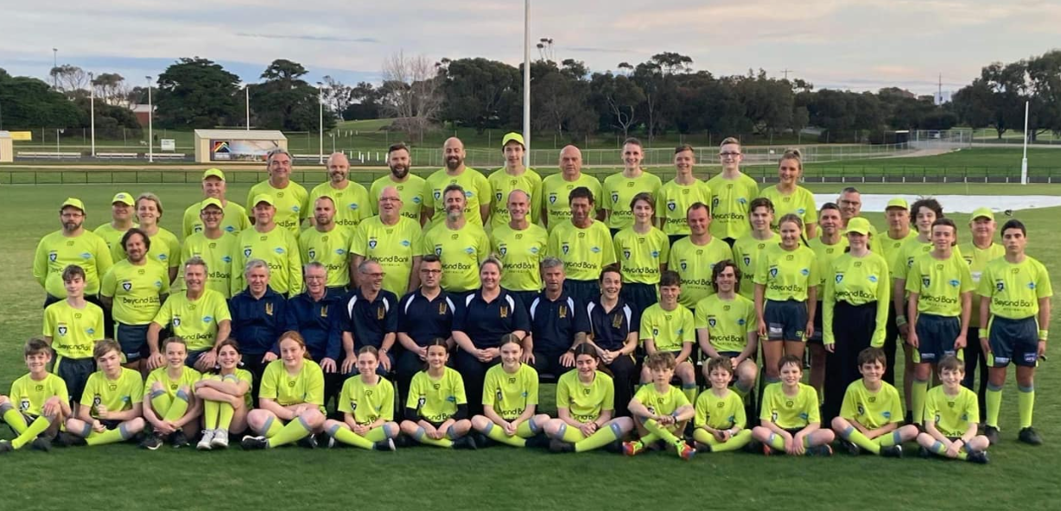
Games Tally
Games total brought forward:
Field |  |  | Boundary |  |  | Goal |  | Inter |  |  |  | Total
Date | Round |  | Grade | F/B/G/I |  | Teams |  |  | Vs | Teams |  |  | No:

Valued Sponsors 2023

